**Project Overview: -**

The dataset involves various features:

1. Car Brand ---- Hyundai, Volkswagen, Maruti, TATA, Tesla, BMW, Mercedes, Skoda etc…
2. Year ---- Years of usage
3. Sold Price ---- Price at which the car can be sold
4. Current Price ---- Price at present
5. Kilo-metres driven
6. Fuel type ---- Electric, Petrol, Diesel
7. Seller type ---- Dealer, Retailer
8. Transmission type ---- About emission
9. Owners ---- Past owners

Through all these information we need to train a machine learning model such as lasso and linear regression which can analyze the fed data of a car and can predict its possible price at these conditions.

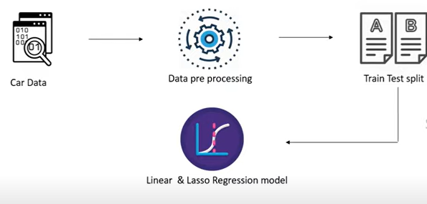**Work Flow: -**

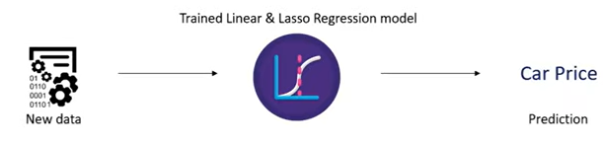

I have also implemented XG Boost Regression model to tarin and test car dataset. After checking the accuracy score it can be inferred that XG Boost Regression model is ideal for predicting Car price. Also solely developed a model evaluation code snippet to show the predicted value through three regression models.

**Results: -**

* Accuracy of training data by linear regression: - 87.9945%
* Accuracy of testing data by linear regression: - 83.6576%
* Accuracy of training data by lasso regression: - 84.2785%
* Accuracy of testing data by lasso regression: - 87.0916%
* Accuracy of training data by XG Boost regression: - 99.1058%
* Accuracy of testing data by XG Boost regression: - 97.2052%

|  |  |  |  |  |  |
| --- | --- | --- | --- | --- | --- |
| SL.NO. | Model Name | Actual selling price | Linear_reg  prediction | Lasso_reg  prediction | Xg_boost_reg  prediction |
| 1. | Ritz |  |  |  |  |
| 2. | Ciaz |  |  |  |  |
| 3. | Sx4 |  |  |  |  |
| 4. | Ciaz |  |  |  |  |
| 5. | Sx4 |  |  |  |  |
| 6. | Ciaz |  |  |  |  |
| 7. | fortuner |  |  |  |  |
| 8. | Corolla artis |  |  |  |  |
| 9. | fortuner |  |  |  |  |
| 10. | Etios g |  |  |  |  |
| 11. |  |  |  |  |  |
| 12. |  |  |  |  |  |
| 13. |  |  |  |  |  |
| 14. |  |  |  |  |  |
| 15. |  |  |  |  |  |